# **Neural Network Layer**

1st Hidden Layer

2nd Hidden Layer

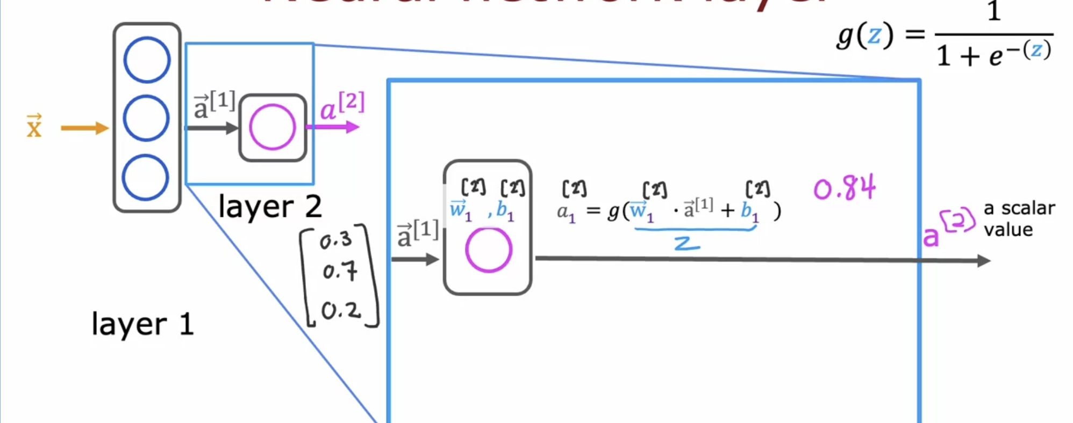

Over-all summary

# **More Complex Neural Network Layer**

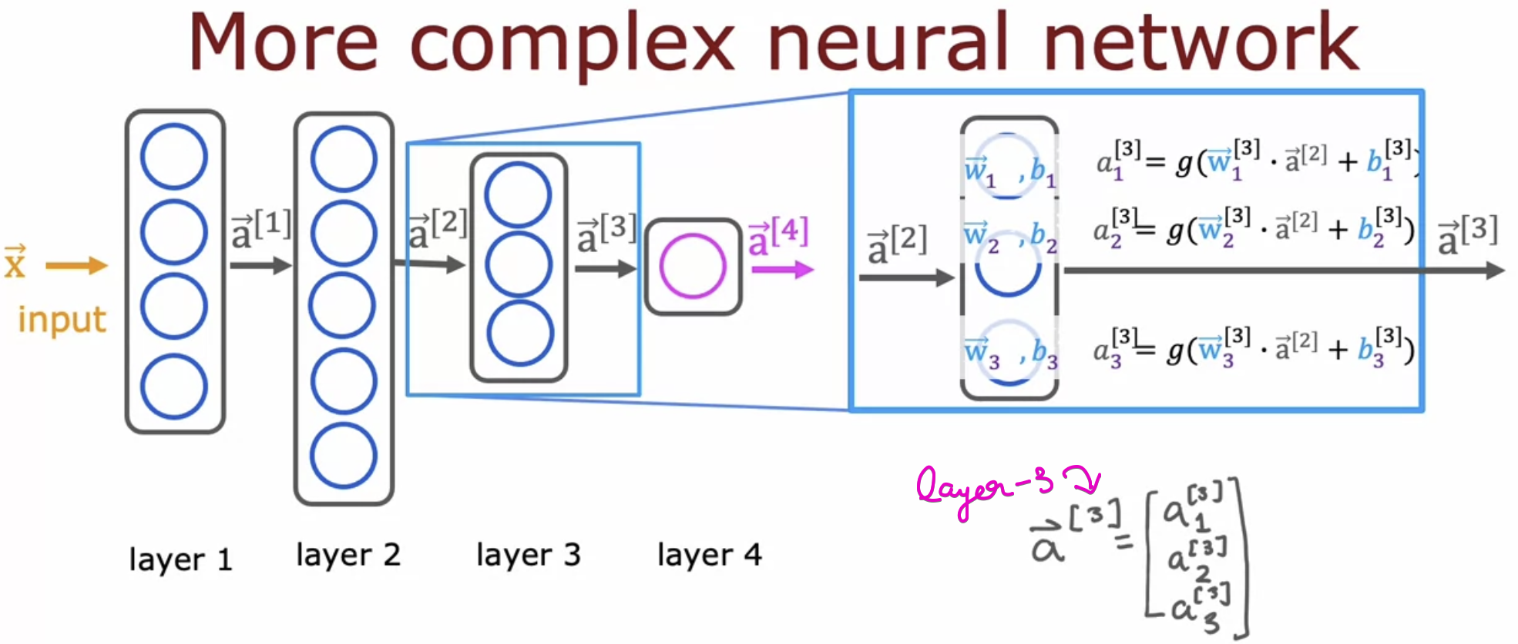

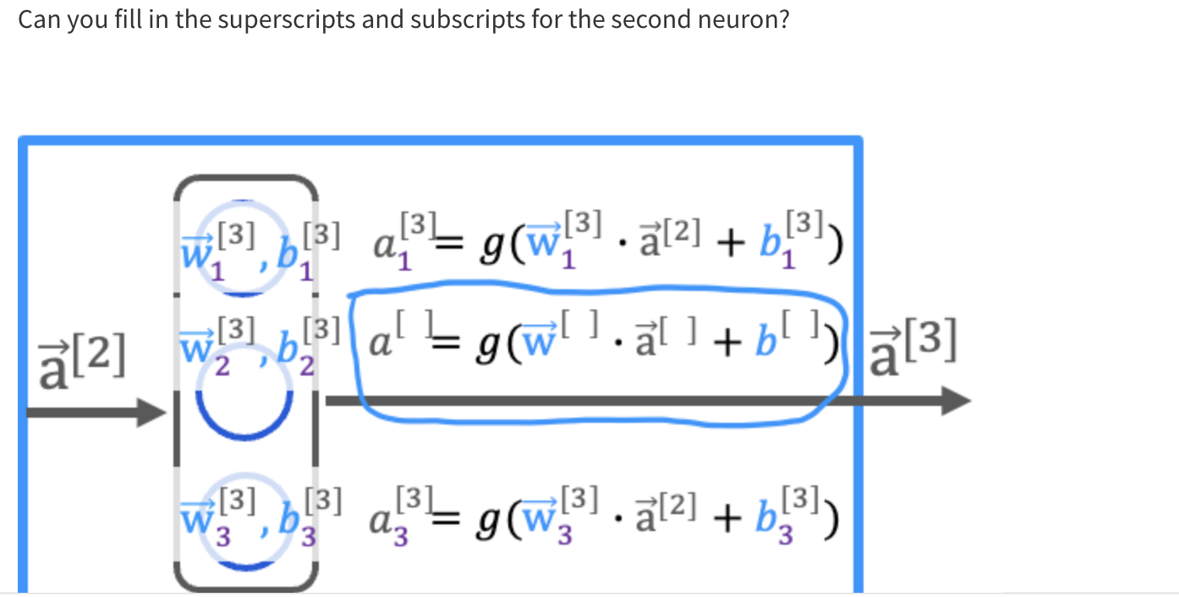  
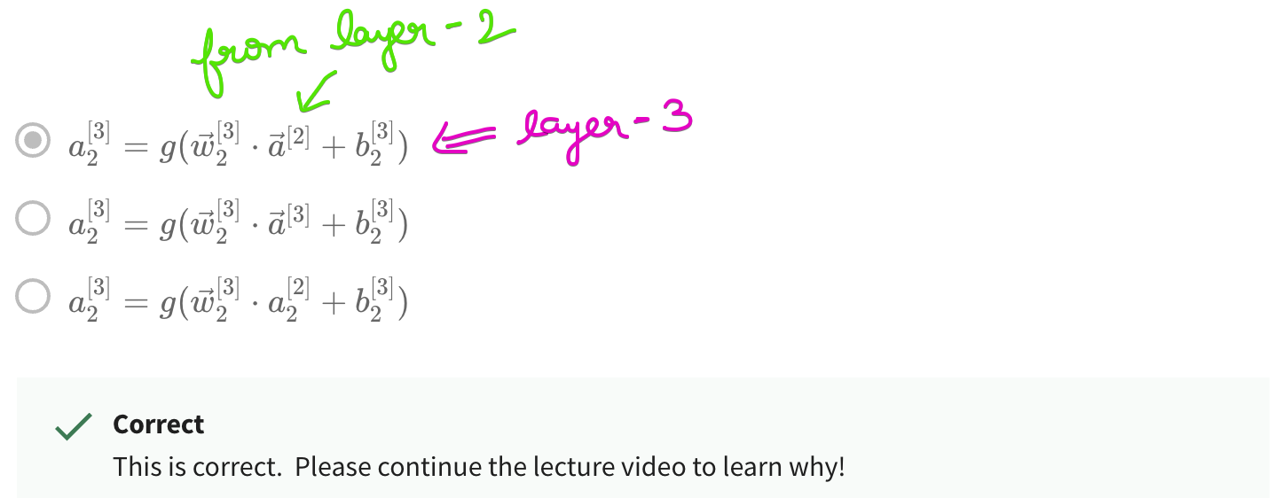

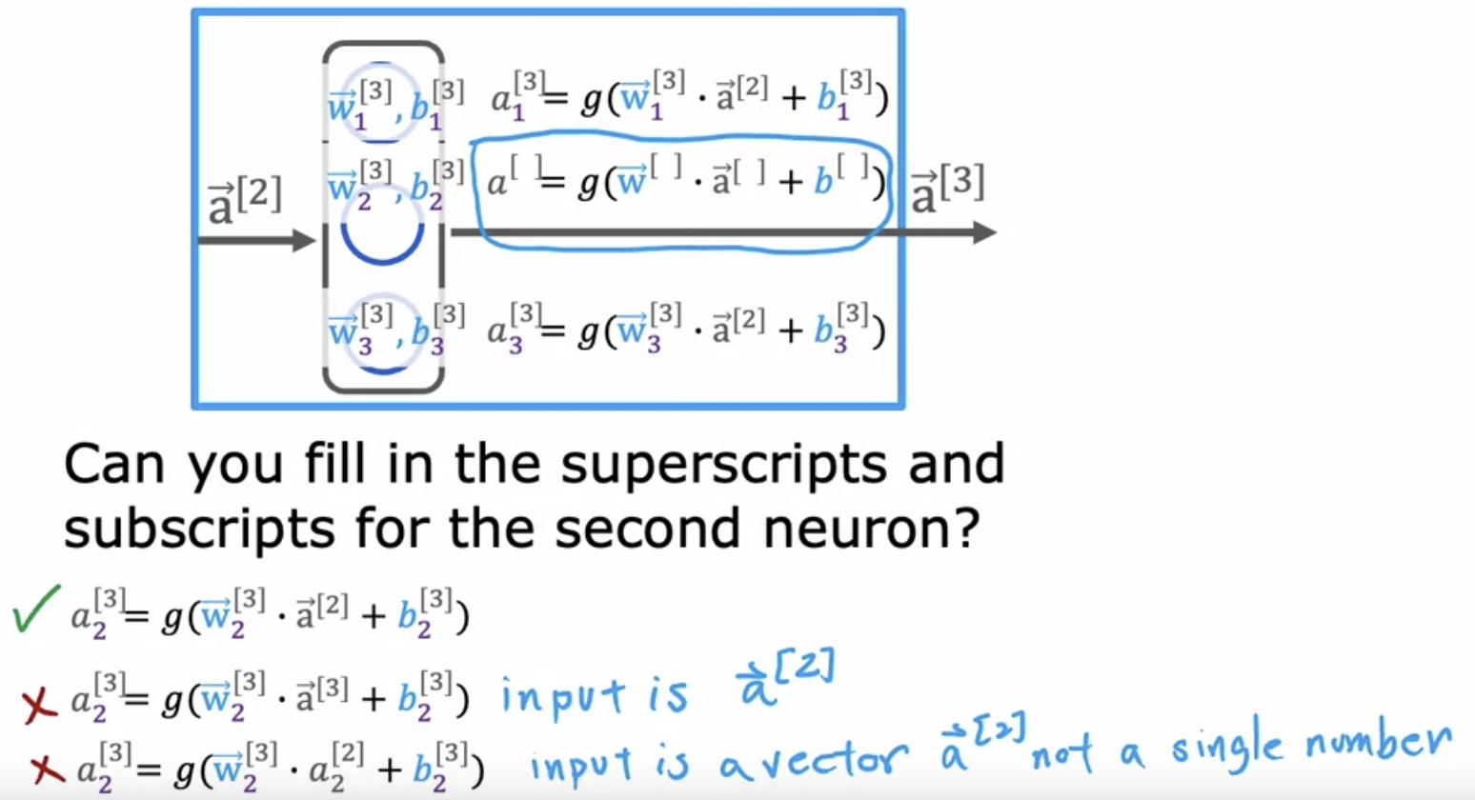

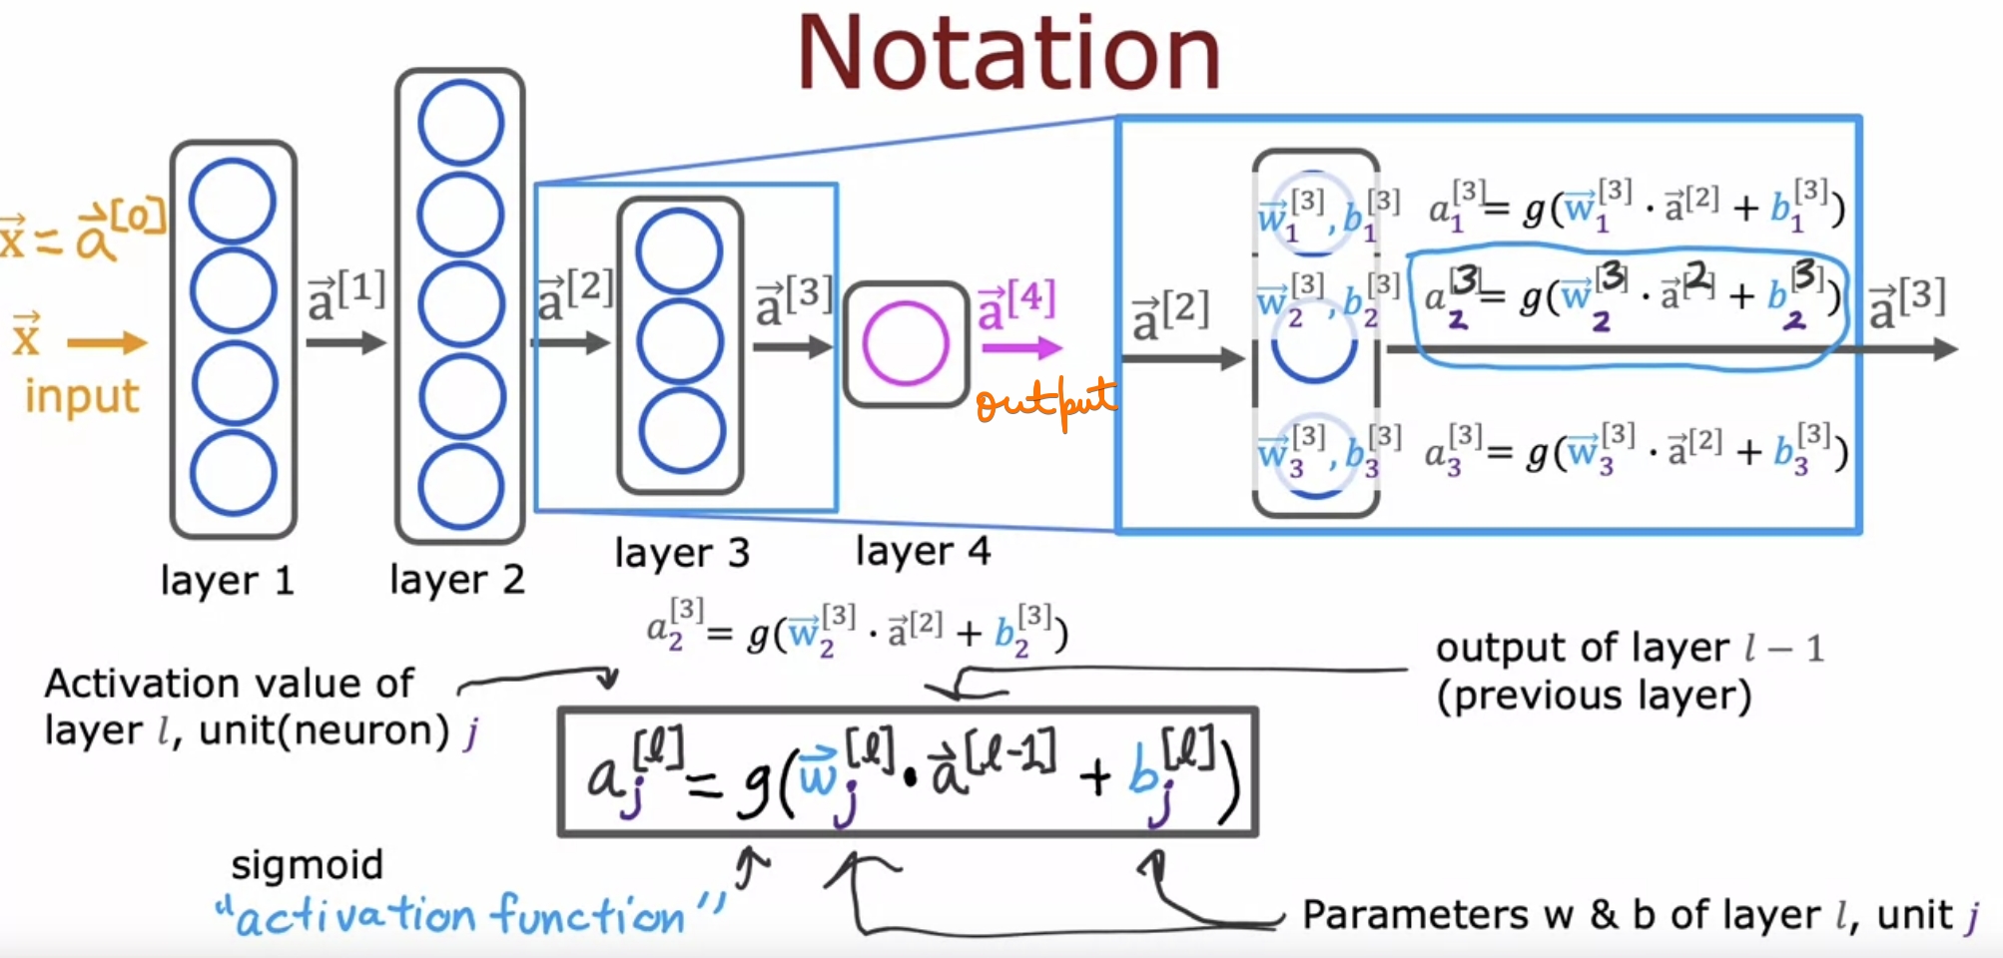

# **Inference : Making predictions**

# **Neurons and Layers**

# **Quiz**



